Parent Questionnaire results October 2015
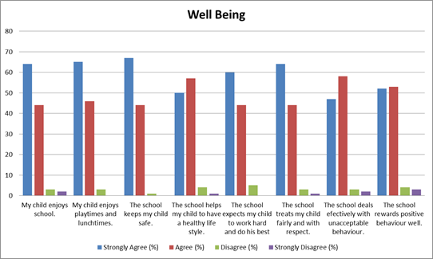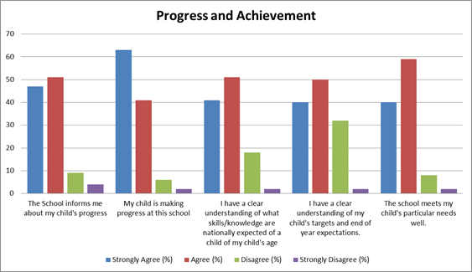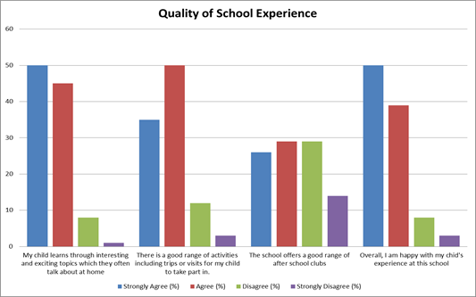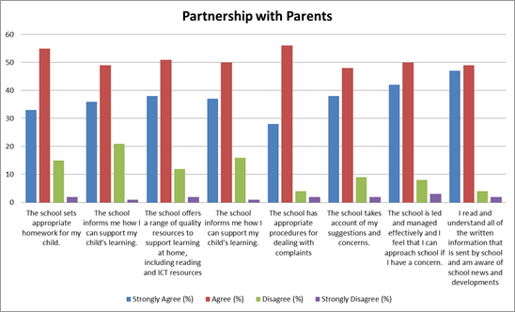
Highlights
- Well-being of pupils scored highly amongst the majority of parents with 110/115 strongly agreeing or agreeing with the following statements
- my child enjoys school
- the school keeps my child safe
- the school treats my child fairly and with respect
- Progress and Achievement, a minimum of 90/115 parents strongly agreed or agreed with all the statements, the highest scoring statement was
- my child is making progress at this school with 106/115 parents strongly agreeing or agreeing.
- Partnership with parents, 80/115 parents strongly agreed or agreed with all the statements, the highest scoring statements were
- I read and understand all of the information that is sent by school and am aware of school news and developments.
- the school sets appropriate homework for my child.
- Quality of school experience, 96 parents strongly agreed or agreed with
- My child learns through interesting and exciting topics.

Areas for Development
- Progress and achievement, between 20 and 30 parents didn’t agree with these statement
- I have a clear understanding of what skills and knowledge are nationally expected of a child of my child’s age
- I have a clear understanding of my child’s targets and end of year expectations.
- Partnership with parents, between 15 and 20 parents didn’t agree with these statements
- The school sets appropriate homework for my child
- The school informs me how I can support my child’s learning
- Quality of school experience, 42 parents didn’t agree with this statement
- The school offers a good range of after school clubs

You said... | We did...
Some parents felt school needed to inform parents more on how they could support their child's learning  Some parents felt school didn’t set appropriate homework  Some parents felt the school didn’t offer a good range of after school clubs  Some parents said they didn’t have a clear understanding of their child's targets and end of year expectations | School had already put in place phase workshops to inform/support parents with the new maths curriculum and phonics in Reception. New maths homework books were sent home and explained in the phase workshops. Further phase workshops for Computing are planned For Autumn 2 (see key dates overleaf)  School has introduced a new homework system that allows all children to access the appropriate amount of homework for themselves and their family life. Parents are always welcome to provide and complete additional homework with their children is they wish.  School has introduced a new system to ensure high quality after school sports coaching is available to all children in KS1 and KS2. Every child has the option of attending a 6 week specialist coaching sports club at no cost. Music clubs have been introduced and are been led by specialist teachers. Further clubs will become available throughout the year  School held a parent consultation day where a letter was produced explaining the new assessment without levels system school has implemented. Time was taken by all staff to discuss in detail the new system, where the children are currently and their end of year targets.

