Ecological impact assessment for Cookridge Primary School: garden, field and perimeter area (onsite).

Environmental Impact Assessment

Site: Cookridge Primary School

Cookridge is a suburb of north-west Leeds, West Yorkshire, England. On site, where all of our Forest School activities will be taking place, we have abundance of flora and fauna. As demonstrated below.

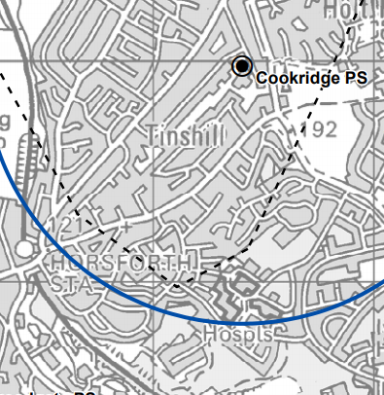
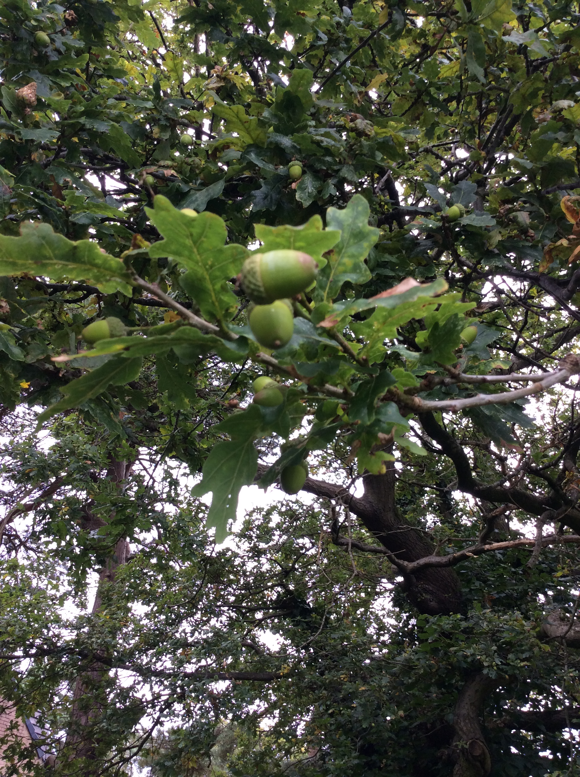
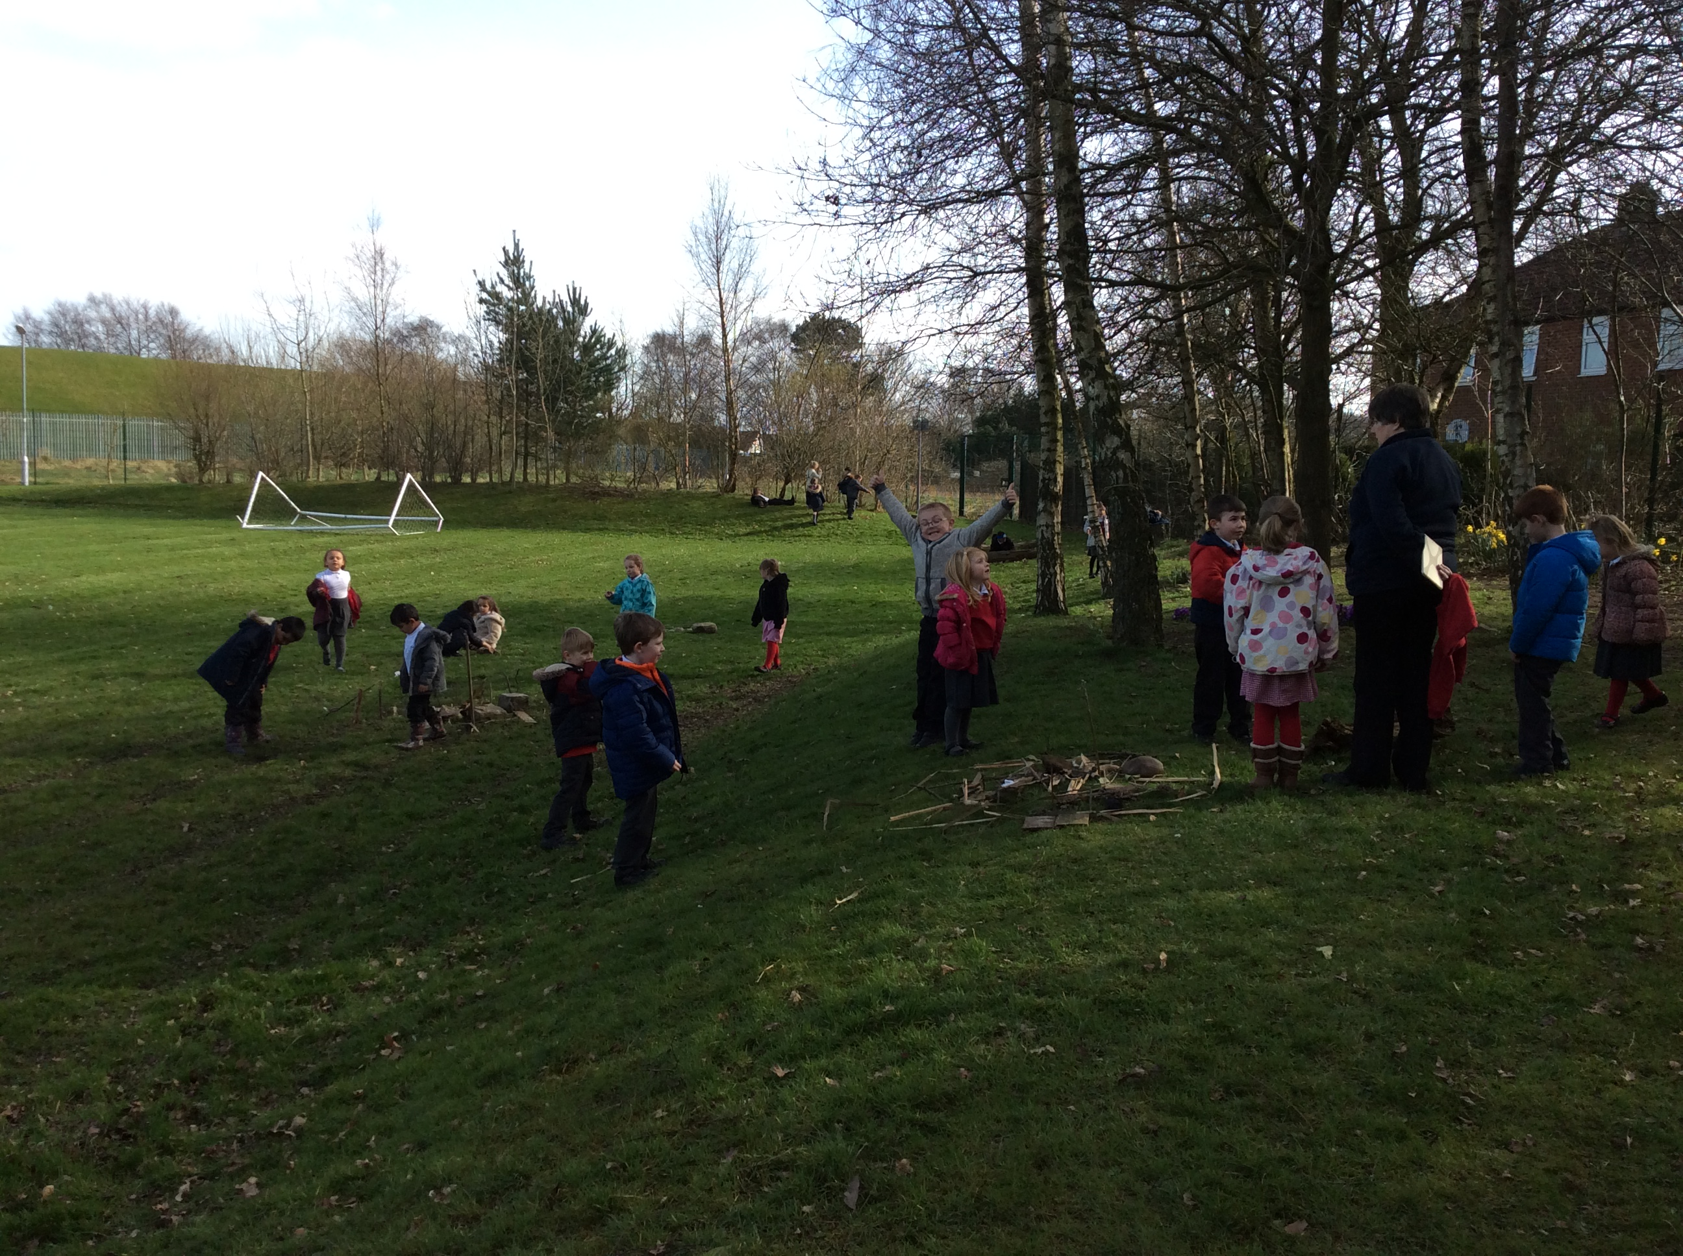

Access to the site is exiting the main building through double doors opposite Class 9. On site there are established pathways towards both the field and garden area. An abundance of trees border the whole site and are prevalent in the garden area.

Initial Review

Forest School activities will take place every week during the course of the year with around 30 children and 3 adults using the garden. The use of fire on site will be limited to the fire pit area and the use of a Kelly kettle where the fire is completely enclosed within a metal base so this will not impact significantly on the site. There is ample dead wood within school to provide fire wood for the programme without having any negative impact on wildlife. The main impact of the project will be trampling and disturbance to wildlife.

The only prevalent ground species is woodland grasses. Daisies are present on the field during spring as well as dandelions. For the sessions taking place in November and December to March, there will be no trampling threat, however during spring and summer extra caution will be needed. There is active management by the school, caretaker and SLT in certain areas and close contact is important to ensure that relationships as well as Health and Safety considerations are adhered to.
The most established layer of the woodland borders the perimeter of the site. Predominate species are oak, mountain ash, sycamore and with smaller amounts of other large deciduous trees. There are several small coniferous trees but the majority of trees are broadleaved.

In terms of fauna we have a chicken coup towards the back of the garden area. There are no fauna sets or nests living on site. The likely impacts of the project will not impact significantly on any natural habitats.

The school site is not under any kind of special protection or status such as SSSI or NNR and no trees have tree preservation orders. Currently the school uses the field, garden and perimeter trees for a range of programmes. Such as training and outdoor learning so we will be monitoring issues of over-intensive use as the initial sessions progress.

Impacts of programme and mitigation measures

Potential Impacts | Mitigation Measures
Trampling impact to ground flora | Use pathways already established in woodland, especially during spring (bluebells). Identify any vulnerable areas and avoid them.
Disturbance/habitat destruction of flora and fauna | Make participants aware of the environment they are in and how to treat it in terms of handling plants and animals and using natural resources. No ground level habitats.
Overuse of fire area/shelter area | If ground is becoming trampled/ compacted move these to other areas. If any further Forest School sessions take place rotate the fire circle and shelter locations.
Use of natural materials for activities | Only what is required will be taken where there is abundance of that resource

Possible Positive Impacts

Further establishing footpaths and improved access – The footpaths have become trampled in places making the woodland harder to use for the nursery as they get very slippery. The Forest School leader will ensure that alternative access paths are identified and ensure there are no unacceptable health and safety risks.

Litter picking – Removing litter from areas will take away a threat to wildlife as well as making the school more aesthetically attractive.

Improved habitats – Forest School sessions might involve positive habitat effects e.g. there is a large herb area. This could be extended through forest schools activities.

Monitoring and Findings

Access path – the access paths became very muddy during the sessions and were becoming eroded so after the 6th session we used an alternative entrance to the garden. For future sessions taking place in the winter months or in a wet period it would be advisable to rotate use of these two access points to ensure minimum erosion.

Fire Pit – the fire pit had very little or no ground flora when the sessions began and there was no lasting impact on these areas at the end of the sessions. To protect the area weed mesh was laid down which was covered by bark.

Three year sustainable woodland management plan for the Forest School area based on our ecological impact assessment

Information collated for the environmental impact assessment gives a clear indication of some management activities which could enhance the garden and contribute to its long term sustainability. Below is detailed a simple management plan for the next 3 years with suggested activities and management methods. The time scale of the management plan commences in September 2017 – during the Forests School sessions onsite.
Factor | Location | Current state | Target state | Any preventative measures | Monitoring | Management required | Timescale
Access | Two access points marked on the garden map | Two access point paths become very muddy in winter and overgrown in the summer. Internal paths are well established and in good condition | To make access paths useable all year round | To rotate use of entrance paths | Review each term with members of the FS group | Edge paths with wood from woodland and lay bark. Prune vegetation annually – this will be carried out by SLT and FS groups. | Year 1 – prune vegetation and begin to create path edging using wood from the woodland  Year 2 – prune vegetation and finish path edging.  Year 3 – prune vegetation and lay bark on fire pit. Complete any maintenance of path edging.
Deadwood | Throughout site | There is some wood on the site floor as well as standing deadwood. | Utilize deadwood for habitat piles | N/A | monitor and add to habitat piles annually | Collect deadwood and create habitat piles | Year 1 - Collect deadwood and create piles  Year 2 & 3– Monitor piles and add to them, create new piles if appropriate

