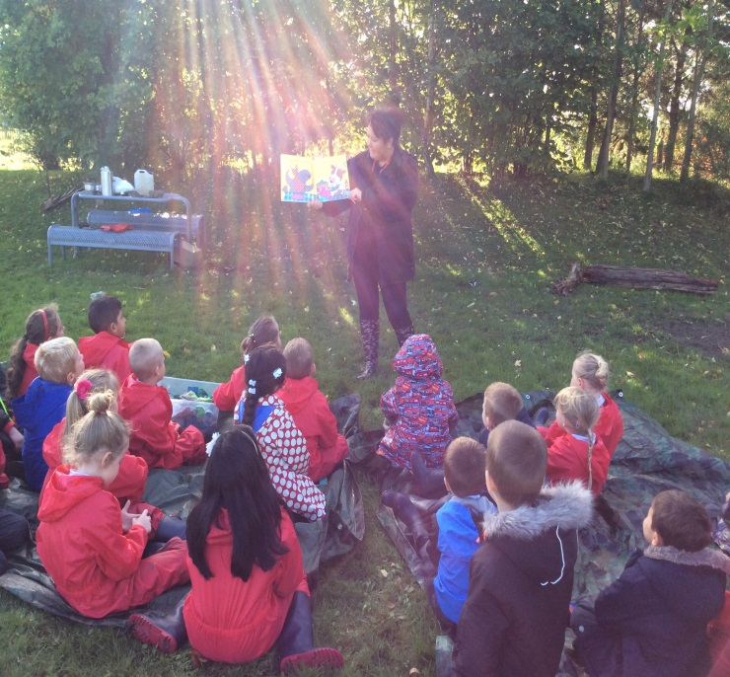
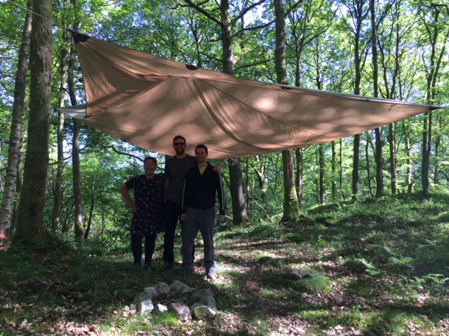

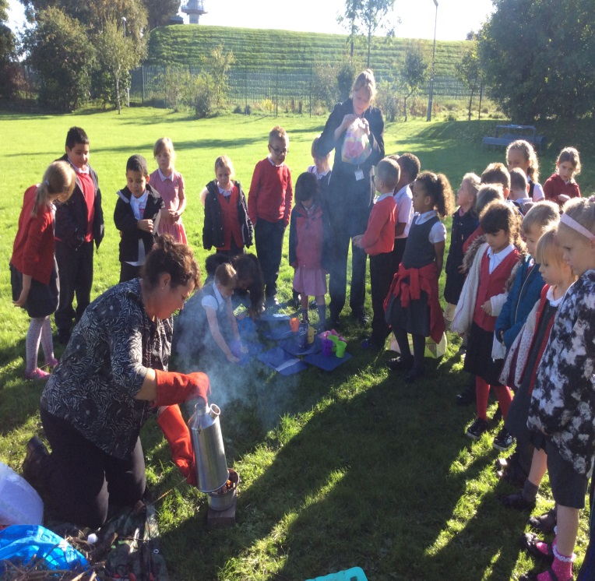
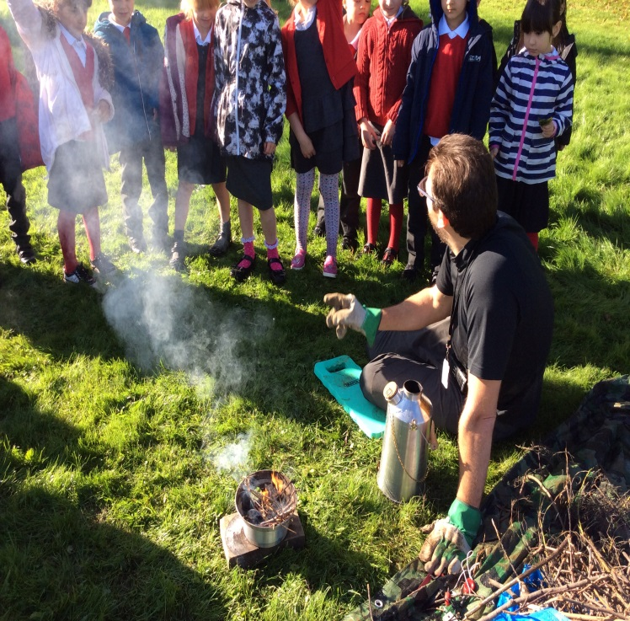

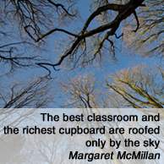
Forest School at Cookridge Primary
At Cookridge our aim is to provide the pupils with a number of experiences that will bring pupils closer to nature, new skills and strengthen friendships. Forest School sessions start in a safe environment where the needs of the group are met. All pupils are equal and feel valued during every activity. We believe the sessions should involve the same group of pupils on a regular basis and that they are given the opportunity to revisit the same activity.
During sessions the role of the class teacher is one of a facilitator providing opportunities and encouragement for pupils to learn through play and exploration. Sessions are child-led and session plans allow for flexibility with practitioners prepared for and encouraging pupils to deviate from planned activities. Forest school sessions are led by our staff that have an understanding of practical skills and activities. As well as learning about the natural environment and developing practical skills, sessions provide opportunities for pupils to develop their self-awareness, social communication skills and emotional intelligence.
Forest school sessions involve pupils reflecting and reviewing both experiences and activities. This supports confidence building and communication skills. Feedback from learners is taken into account when planning future sessions and teachers are flexible if that feedback requires deviation from any planned activities.
Pupils will have opportunities to take appropriate risks, such as tool use and fire lighting .These opportunities will build self-confidence, allow children to learn and develop their physical and mental resilience and make them better equipped to handle risk.
Pupils are taught to take responsibility for themselves and for others. They are encouraged to think about how their actions could have a direct link to other people. Through the use of tools the pupils are engaged with the direct responsibility that they have a peer next to them. They are taught about the cause and effect of what they are doing. They become aware of the things that may happen if they are irresponsible with the tool that they are using. In a controlled environment they are trusted to follow the rules shared with them. The whole philosophy of Forest Schools is supported by the engagement between the people who are taking part, whether working independently, in a group or with one other person. The interaction between those in the group develops a bond that cements them as a team, enabling each member of the team to believe in themselves as well as feel equal and valued. `
Research continues to show that the amount of freedom pupils are given and the time they spend, freely and independently, playing outdoors have both decreased over the years with a significant number of pupils having never built a den or climbed a tree. The term ‘Nature Deficit Disorder’ has been used to describe this phenomenon and draw attention to the impact this lack of contact with the natural world is having on pupils and young people. We believe access to Forest School, for the benefit of our pupils is increasingly important – especially the importance of play.

The importance of ‘Play’
“Play is the highest form of research.” Albert Einstein
“States Parties recognize the right of the child to rest and leisure, to engage in play and recreational activities appropriate to the age of the child and to participate freely in cultural life and the arts.”
UN Convention on the Rights of the Child Article 31
We believe by permitting children to choose how they play and interact with the natural environment Forest School Leaders can support, develop and extend play and learning. If children are allowed to explore and share ideas naturally they’ll try to solve problems and cultivate an atmosphere of working in teams. Allowing children to work together and tackle perplexing problems helps them to learn more effectively.
As a consequence, independent play gives children the chance to ‘gather information’; they can test things out, find new ways of doing things which helps to build self-confidence and self-esteem. Additionally, pupils also have a chance to develop friendships by learning how to collaborate together.
Although play may seem directionless to a spectator, pupils’ experimentation with objects and materials around them unlocks potential and curiosity. This cognitive and developmental perspective, in which play is important for intellectual growth and development of thinking and understanding, underpins our school ethos (Else and Sturrock 2007). “Children are born with a natural curiosity and a desire to learn. It is an eagerness to explore, discover and figure things out. The more explorative a child is, the more they learn. Nurturing this curiosity is one of the most important ways we can help children to become lifelong learners.” http://www.cookridgeprimaryschool.org.uk/page.php?id=5626
Forest School practitioners can learn a lot about pupils’ interests by guiding self-directed learning. Moreover, this is assists practitioners to find a starting point which builds a relationship and shared interests. Subsequently, this knowledge facilitates the Forest School Leader to develop activities which will not only build on pupils’ natural interests but also support them to develop further thus amassing knowledge.

Roles and Responsibilities of Staff:
- Promote and provide Forest School experiences which adhere to and apply the principles of the Forest School ethos.
- Adhere to school polices found under key information (on our website).
- Ensure appropriate welfare requirements are in place for the group (clothing/shelter, hand washing, drink & food, toilets).
- Communicate with all stakeholders, including landowners, other staff, parents, management, participants, local community etc.
- Ensure appropriate ratios are maintained and provide clear guidance and induction processes for helpers supporting their Forest School programme, to ensure a consistent approach.
- Share planning and evaluations of sessions recorded with relevant staff. Record observations of individual learners learning processes and share with other relevant staff. Reflect on their own practice; undertake continued professional development and network with other local Forest School practitioners.
- Undertake a baseline ecological survey of the Forest School site, establish environmental impact monitoring systems and create a simple management plan for the site for the duration of the programme.
- Implement the management and maintenance of our Forest School area.
- Ensure that equipment, tools and outdoor clothing are fit for purpose and appropriately stored.
Adult ratios
All classes adhere to appropriate ratios from Early Years to Upper Key Stage 2.
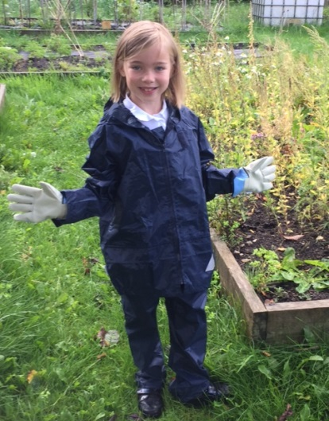
Protective Clothing
To ensure that all pupils are able to access the Forest School’s activities, we have a stock of waterproof trousers and coats plus durable gloves. However we ask that both parents and pupils think about the usefulness of their clothing for outdoor activities, and to be aware that they are likely to take some of our mud home with them after a session at school.
Medical Needs
Pupils with medical needs or disabilities will be helped so they can take as full a part as everyone else in Forest School sessions. Those with challenging behaviour are risk-assessed and may need one-to-one supervision, but their entitlement remains the same.

Policies
All relevant policies can be found on our website under: Key information: Policies. Below is a summary of policies that have an immediate bearing on Forest School activities.
Toilet policy
On Site Toileting Procedure
Pupils are toileted before any forest activity begins. If they need the toilet during a session normal school procedures are followed.

Safeguarding (see school website for policy)
Cookridge Primary School recognises that safeguarding encompasses the duties of child protection and promoting the rights and welfare of pupils. As such, it is:
- Everyone’s responsibility to safeguard pupils
- Everyone who comes into contact with pupils and families has a role to play
- Everyone working with pupils maintains an attitude of ‘it could happen here’ (Keeping Pupils Safe in Education, July 2015).
And we believe:
- Schools can contribute to the prevention of abuse.
- All pupils have the right to be protected from harm.
- Pupils need support which matches their individual needs, including those who may have experienced abuse.
- Pupils need to be safe and feel safe in school.
Any volunteer, or member of staff, who finds that a child is telling them something that concerns them should follow the course of action set out below in simple steps:
1. Listen to the pupil but ask NO leading questions. Allow the child to lead the discussion but do not press for details.
2. Keep calm and offer reassurance. Accept what the child says without challenge.
3. Make NO promises. You cannot ‘keep a secret’. You should make it understood that there are limits to confidentiality at the start of the disclosure.
4. Inform the Child Protection Officer (the Head teacher, Mrs Hunter) or a designated child protection officer.
5. Keep an accurate, written record of the conversation, including the date, the time, the place the conversation occurred in and the essence of what was said and done by whom and in whose presence. Keep the record secure and hand it to the CPO.

Equal Opportunities and Inclusion Policy
We are committed to giving each child the tools and the opportunities to achieve, irrespective of ethnicity, religion, attainment, age, disability, gender or background. We actively seek to remove the barriers to learning and participation that can hinder or exclude individual pupils or groups of pupils. The Forest School programme promotes pupils’ right to be strong, resilient and listened to by encouraging pupils to develop a sense of autonomy and independence. All pupils will be respected and their individuality and potential recognised, valued and nurtured. Forest School activities and the use of Forest School equipment will offer pupils the opportunity to develop in an environment free from prejudice and discrimination.
We will:
- Ensure equality of access for all pupils
- Employ a range of styles, including collaborative learning, so that pupils can value working together. Seek to involve parents in their child’s education.
- Take account of the achievements, strengths and challenges of all pupils when planning for future learning and setting challenging targets.
- Make best use of all available resources to support the learning of all groups of pupils.
- Ensure a common curriculum experience that allows for a range of different learning styles.
- Set challenging targets that enable them to succeed.
- Support the pupils to enable them to participate fully, regardless of disabilities or medical needs.
Behaviour
All behaviours that pupils display are individual to each child and often there are underlying reasons for why a child choses to display behaviours that are not consistent with the rest of the group. Therefore under the right conditions we can help them with different coping strategies, instead of reverting to their ‘most common’ behaviour. Forest Schools is about the whole child, therefore by generating conditions where by the child is given another option we are sharing a new strategy. Forest Schools is about developing all aspects of a child’s personality, including emotionally therefore allowing their self-esteem to increase and allow them to make other choices when they meet challenges. School behaviour expectations will be followed: Listen when adult is talking; Take turns when talking with your peers and listen to what they have to say. Keep yourself safe – look around you – take care. Keep your friends safe too. Use Forest School language – kind words always and be polite. Be patient with each other, everyone learns at different rates.

Behaviour Policy
Teachers and adults always model positive behaviour to generate and maintain a positive atmosphere at school. The pupil must be considered separate to their behaviour. Prior to any session mutual behaviour guidelines will be agreed. Positive behaviour management must be maintained at all times. We make sure there is time for participants to discuss their feeling/issues. The tasks will be planned to ensure that they are achievable and do not set participants up to fail. Coping strategies are to be developed with participants who display challenging behaviour to allow them to choose to make a ‘better choice’ instead of their habitual one. Sanction procedures are clear and open. We ensure pupils’ achievements are praised. Teaching methods are well matched to the child’s needs both academically and socially.
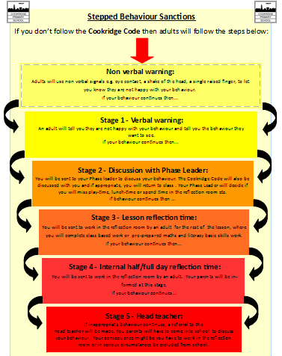
Follow procedures of Cookridge Primary School behaviour policy
1. Non Verbal Warning
2. Verbal Warning
3. Discussion with Phase Leader
3. Reflection Time (Blue Room)
4. Head teacher
Behaviour that the teacher deems dangerous will result in the learning mentor or a member of SLT being radioed.
Fire Policy
Fires are an important part of Forest School and are used in some sessions. Cookridge Primary School aims to ensure that all pupils and adults participating in Forest School sessions with fires will do so safely and with as little risk to their health as possible. (See risk assessment- attached).
Fire Circle - Seating
The area will be assessed by the teacher before use and the log seats are to be checked for stability before the pupils arrive.
The rules and safety talk about exiting and entering the fire circle must happen before
each session and the fire is lit.
The pupils must be reminded how to step out of the fire circle and NEVER cross the
circle, even if the fire is not lit.
The seating area will consist of logs and will be placed 2 meters from the fire perimeter
of the Fire Circle.
No one can approach the fire circle perimeter unless they have been invited to do so by
the teacher.

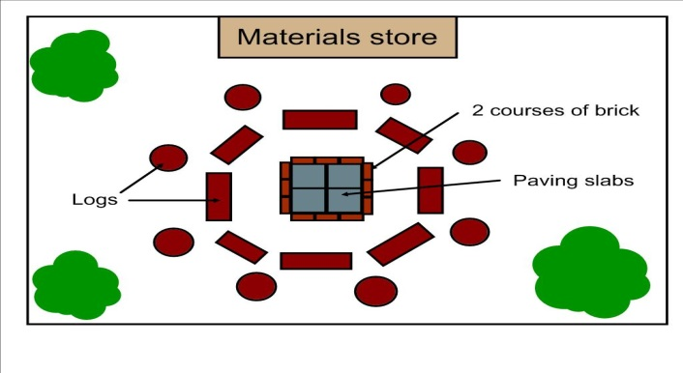
Seating 2 metres away

Entrance to fire circle
Pupils do not approach fire perimeter unless asked by teacher

Log seats must be checked

Positioning of Pupils and Adults Cookridge Primary School
Fire areas are surrounded by seating logs at least 2 metres from the fire pit. When the campfire is in use, pupils are not permitted to access the area without permission. When allowed to access the fire circle, pupils must walk around the outside of the seating logs and wait for permission to step over. Once permission has been given, they must sit, ensuring legs are drawn into the log and not outstretched. Once seated around the campfire, the pupils must remain seated until directed by an adult to move. Pupils will be taught how to change seats by standing, stepping over the log and then walking around the outside of the seating area. They must never cross the inner area. Long sleeves and trousers must always be worn. Pupils are not permitted to throw anything onto the fire. Advice on the appropriate way for dealing with smoke will be given to the pupils: they are advised to turn their head to one side, placing their hand across the face, to close their eyes and count to 30 (or ask an adult/peer to count for them) If there is a clear wind direction, seating in the line of smoke is to be avoided. If wind direction is variable, the leader should rearrange the seating if at all possible.
Insurance: Cookridge Primary School has public liability cover with: Zurich Municipal.
Risk / Benefit Analyses
We believe that, while there are risks that must be considered, there are also a wide range
of potential benefits that can be gained by those involved. We also recognise that taking
risks is an important part of learning and developing and we want to provide a safe and
supportive environment in which participants can learn about risks, challenges and personal
safety. All sites used in 2017 -18 will be on the school grounds.

Ecological Impact Assessment
As a school we have mitigated our environmental impact through careful planning and design of the Forest School area. All staff contributed to creating a safe fire pit area which is on site. All staff have had basic Forest Schools training. Three members of staff are training to become NOCN Level 3 certified. (Please See: EIA Cookridge Primary School on website)

How we have communicated with our parents
All information is available on our website under the Forest School heading. Furthermore, parental information meetings explaining Forest School have been disseminated throughout the year.
Daily Operating Procedure
What to do before each session?
  - Forest School Leader to check that all risk assessments are in place, particularly the
daily risk assessment and carry out appropriate tasks.
  - Forest School Leader to ensure that there is correct staff/client ratio and that all
staff are familiar with this handbook.
  - Register to be completed by Forest School Leader.
  - Forest School Leader to complete equipment check prior to each session.
What to do during the session?
- Ongoing risk assessment – weather, behaviour, safety, activities by Forest School
Leader.
- Head count
What to do after the session?
- Site must be left with no rubbish or equipment or remains of campfire.
- All resources returned and stored in Forest School Shed.
- Tool Check

