Parent App Lite - Parental Setup & Guidance Notes
1. An email will be sent to you by the school, inviting you to become a SIMS Parent App Lite user. You will receive a registration email from noreply@sims.co.uk containing a unique invitation code. If you have not yet received a registration email, please check your SPAM or JUNK folder. You don’t need to make a copy of the code as it will be entered for you.
2. Open the email and click the link as instructed. A new Internet browser window will open and you will be asked to Sign in.
3. Select an existing account of your choice with which you would like to register. Currently, only the options below are available to sign in. If you use a BT or Yahoo email for example, you will need to use another account type from the list below to sign in.
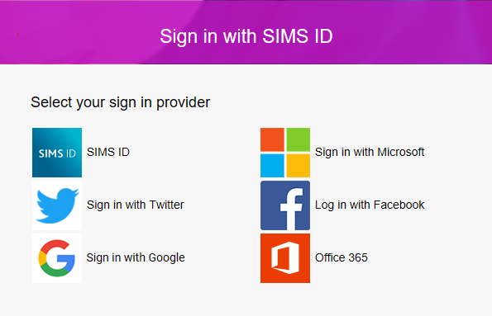
4. Having entered the username and password for the chosen account, you will see the SIMS Registration Form – this should autocomplete, with your name, chosen sign in account and Invitation Code. Select REGISTER.
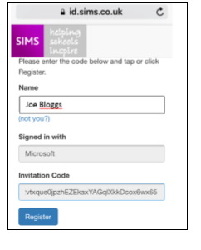
5. You will then be asked for the date of birth of one of your children at the school, in the form DD/MM/YYYY (e.g. 07/09/1977). You may be asked for your own date of birth, but please use the data of birth of one of your children.

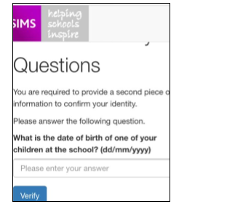
6. You have now registered for SIMS Parent Lite. You can download the app from the Google Play or Apple App store by searching for Sims Parent.
7. Once you have downloaded SIMS Parent Lite, you will be asked to sign in using your chosen log-in account details. Once you have registered you can also use www.sims-parent.co.uk from any web browser.
Navigating the App and making amendments to student and contact information
Once logged into the app from the homepage you can select which of your children you would like to see details for by clicking on their photograph. You will only ever see information on your own children or information on children that live with you and it is recorded that you have parental responsibility for. Key school dates can be viewed in the Calendar.
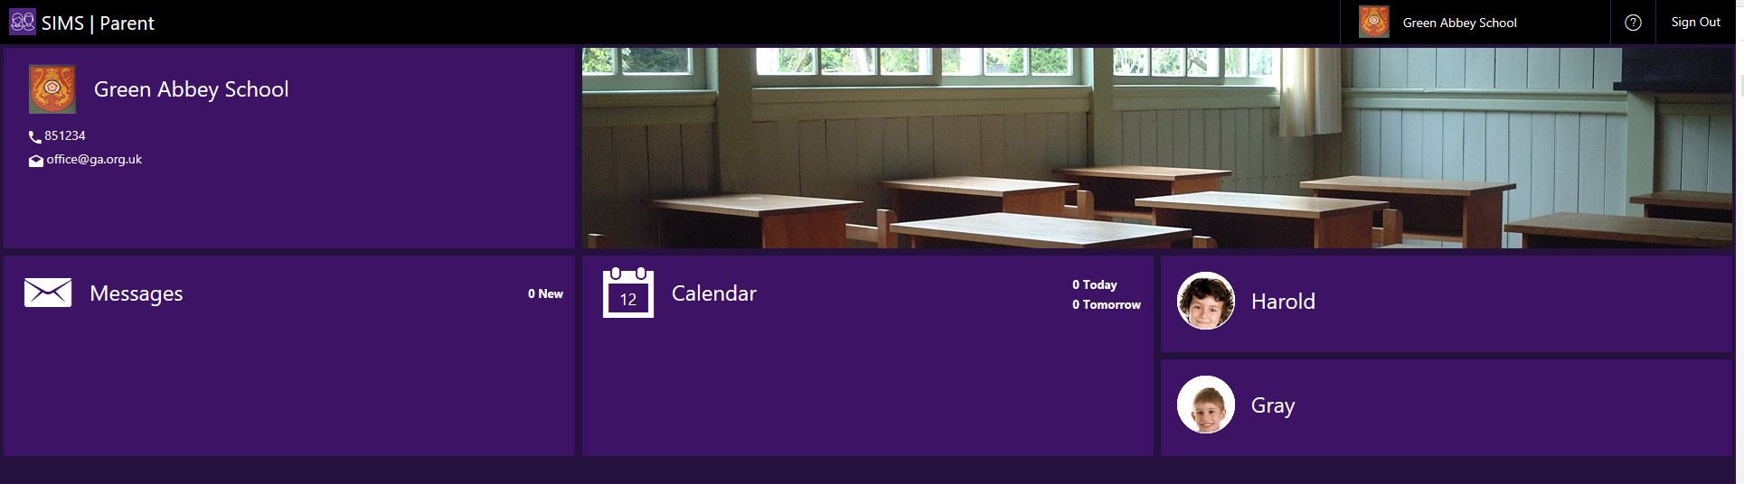
The Data Collection option is used to notify the school of any changes in your or your child’s details.

- Click the Data Collection button to open the Data Collection Menu. 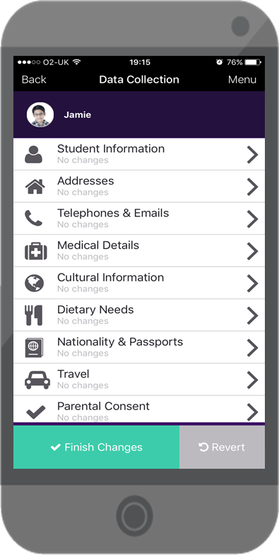

- Move up and down the menu. Each section will provide a further menu or drop-down giving details of the information stored. Some of this information is mandatory.

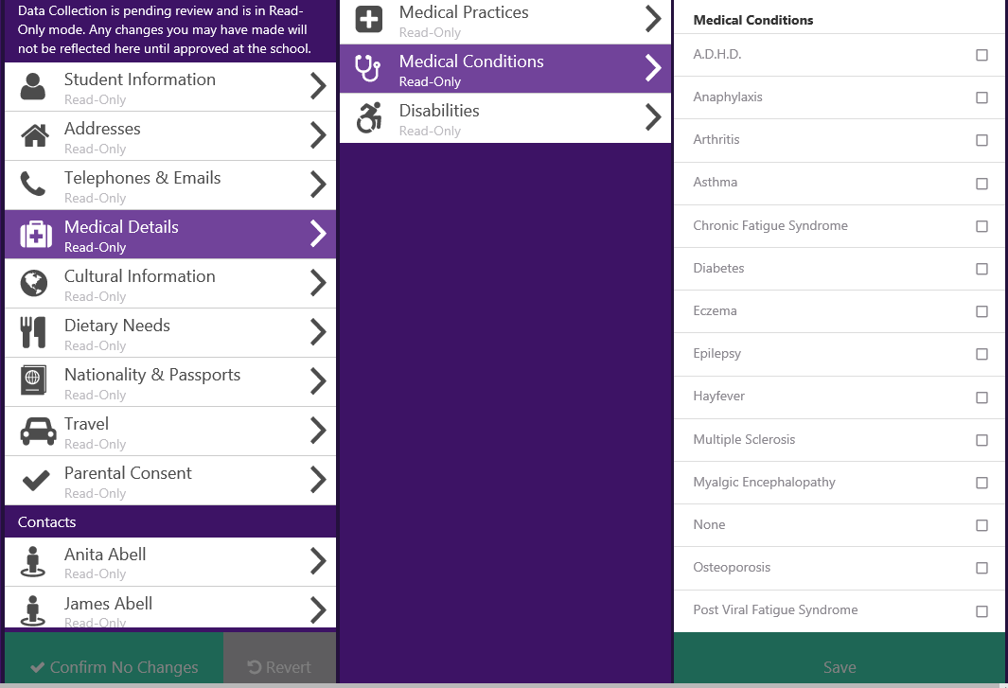

- Make amendments as appropriate and then Save.
After each section you must save using the green button, before moving onto the next section or any changes made will be lost.

Once all changes have been made and submitted via the app you will notice a green padlock in the Data Collection box and you will not be able to make any further changes until the submitted changes have been approved at the school.
