MUSIC
The Wellerman – a sea shanty
Over the next few weeks we are going to be learning and arranging our own version of the sea shanty that has gone viral over the past month.
Voyage 1
We will learn the song and more advanced singers can add the harmony part during the chorus.
Voyage 2
We will learn more about the history and purpose of sea shanties and start to develop own arrangements using body percussion/ homemade sounds/ musical instruments or computer software. More advanced musicians will be able to learn a part on their instrument.
Voyage 3
We will consider why this sea shanty has become so popular in 2021 and why singing is good for our health!
Our main focus will be rehearsing and refining our own arrangements and getting them ready to perform and record!
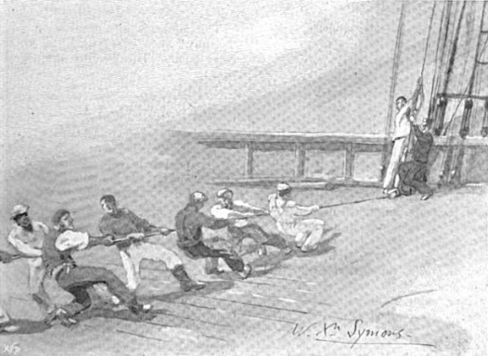

The Wellerman
There once was a ship that put to sea
And the name of that ship was the Billy o' Tea
The winds blew hard, her bow dipped down
Blow, me bully boys, blow
Soon may the Wellerman come
To bring us sugar and tea and rum
One day, when the tonguing is done
We'll take our leave and go.
She had not been two weeks from shore
When down on her a right whale bore
The captain called all hands and swore
He'd take that whale in tow
Soon may the Wellerman come
Before the boat had hit the water
The whale's tail came up and caught her
All hands to the side, harpooned and fought her
When she dived down low
Soon may the Wellerman come
No line was cut, no whale was freed
And the captain's mind was not on greed
But he belonged to the Whaleman's creed
She took that ship in tow
Soon may the Wellerman come
For forty days or even more
The line went slack then tight once more
All boats were lost, there were only four
And still that whale did go
Soon may the Wellerman come
As far as I've heard, the fight's still on
The line's not cut, and the whale's not gone
The Wellerman makes his regular call
To encourage the captain, crew and all
Soon may the Wellerman come
(x2)

