Reading together at home
When you’re reading at home together, here are some suggested questions that you can ask your child before, during or after to help develop and strengthen their reading skills!

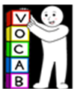 Vocabulary – giving the meaning of words in context
- What does … mean in the sentence?
- What does … suggest about the character, setting or story?
- Can you think of a synonym (a word that means the same) for the word …?
- Can you find a word meaning the same as X

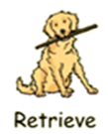 Retrieval – identifying information from the text
- What, Who, Where, When, Why?, How much/many?
- True or false - Using the text, is ………………………………… true or false?
- Why did a character do a particular thing? Can you explain why?
- Can you tell me two or three new things you’ve learnt from what we’ve read today?

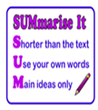 Summarise – giving a brief statement/overview of the main points
- Can you summarise/give me an overview of the story so far?
- What’s the main point of what we’ve read today?
- What happened before/after………………………?

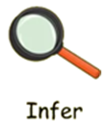 Infer – concluding based on evidence
- How was X feeling when…………………… ? How do you know?
- How did xxx feel when ………………… happened?
- Show not tell: Can you find a sentence where the author showed (not told) that the character was angry/upset/happy?

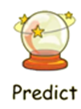 Predict – anticipating what might happen next based on evidence
- What do you think will happen next? Explain why you think this.
- Breaking the story into parts – predict what might happen next using evidence from the part just read, then reveal it.
- Do you think the character will act differently in the future/after this part of the book?

